
React JS Design
Guidelines
V1.0


 | Prepared By | Reviewed By | Approved By
Name | Viswanath Jangala | Surya N V | Kondal Reddy S
Role | SA | SA | SM
Signature | Viswanath | Surya | Kondal
Date | June 29 2018 | June 29 2018 | June 29 2018

Table of Contents

1.0 Introduction 4
1.1 Purpose of this document 4
1.2 Scope 4
1.3 Structure of the document 4
1.4 Intended Audience 4
1.5 Acronyms 4
1.6 References 4
2.0 Application type and design 5
2.1 Simple App 5
2.1.1 Design 5
2.1.2 Description 5
2.2 App with Simple Routing 6
2.2.1 Design 6
2.2.2 Description 6
2.3 Routing with Lazy Loading 7
2.3.1 Design 7
2.3.2 Description 7
2.4 Shared Module/data with Redux store 8
2.4.1 Design 8
2.4.2 Description 9
3.0 Application Flow (With API) 9
3.1 Business Vision 11
3.2 Modules 11
3.3 Components 11
3.4 Metadata 12
3.5 Data binding – via Props or global state 12
3.6 Services 12
3.7 Routing 12
4.0 Front End Design 13
4.1 User Interface Design 13
4.2 Solution Strategy for Cross Cutting Concerns 13
4.3 Project Structure Definition 13
5.0 Backend Design 14
6.0 Consolidated Design View 15
6.1 Request Process Flow 15
6.2 Request – Response Mapping 16
6.3 Requirement – Solution Mapping 16
7.0 Testing 16
8.0 Build & Deployment Strategy 17
9.0 Change History 17

Introduction

Purpose of this document
The purpose of this document to provide design guidelines to build web application using React.

Scope
In Scope The scope of this document includes tools, technologies, patterns and approaches that will be used in the design and development, deployment and support and enhancements (evolution) of the proposed system. It should provide a detailed look at the general implementation design demonstrating the architectural approaches that will be used throughout the system. In cases where concrete decisions on the choice of tools or technology cannot be made at this stage, multiple possible options have been suggested.

Structure of the document
This subsection should detail out the structure of the document explaining how each chapter in the document is organized. It should list the views used and the concerns addressed as part of each of the views defined

Intended Audience
- Development Teams
- Maintenance Teams

Acronyms
This subsection should provide the definitions of all terms, acronyms, and abbreviations required to properly interpret the Architecture. This information may be provided by reference to the project Glossary.

References
https://reactjs.org/
https://github.com/reactjs
https://github.com/facebook/react

Application type and design

Simple App

Design
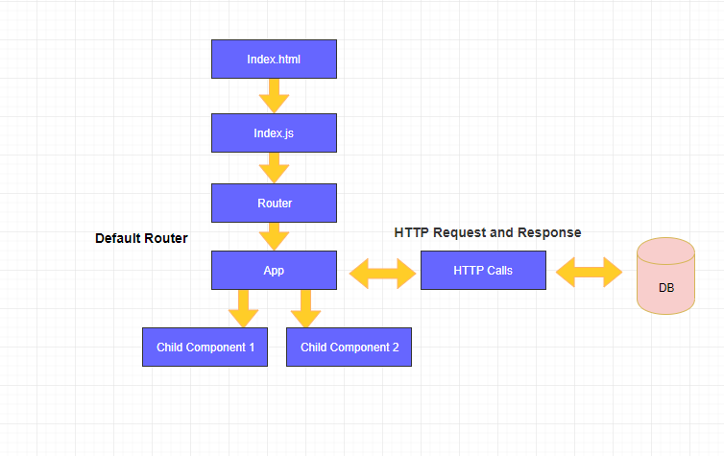

Description
  - The Simple React app construct upon only one module and components. All the components exported by default so all the components will be available to use
  - App is the parent component and it is having two child components.
  - AppService is the only provider for the entire application.
  - App Component is accessing the AppService for HTTP request, so data is available at component. Data shared to child component from App through props.
  - Child Components should not access data from AppService, it GET and POST data through App components only.
We have different life cycle hooks to update component.

App with Simple Routing

Design
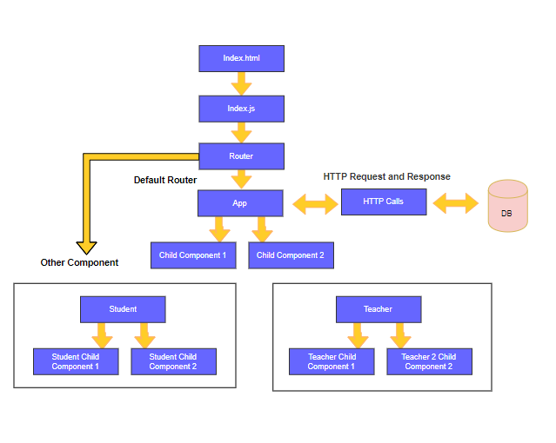

Description
  - This application deals with simple routing between components. App construct upon only one module. All the components exported in index.js page for the module so accessible throughout the module.
  - Based on the routing path, Component will be placed in router outlet. Router outlet will behave like a placeholder for component.
  - In above diagram Router outlet holding component Student since user moved from App to Component Student. Child Components are mentioned in Parent component’s templates like a HTML element.
  - Http Calls is the only provider for the entire application.

Routing with Lazy Loading

Design
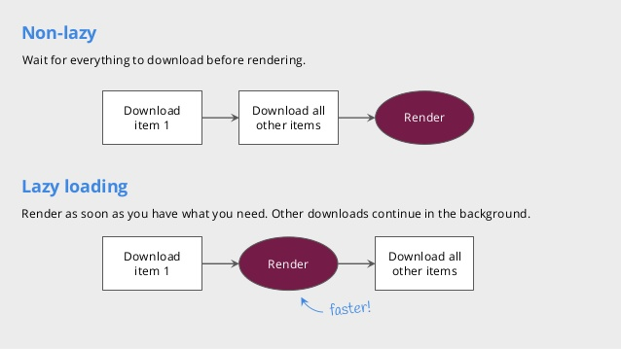

Description
The main aim of lazy loading, render downloaded items later download or fetch remaining items, this loop will be continuing till the end.
For example, above diagram we have two variations
- Non-Lazy
- Lazy loading

In Lazy loading, first required components/modules will be downloaded and corresponding render function will be invoked. Later same cycle will be repeated.

Shared Module/data with Redux store

Design
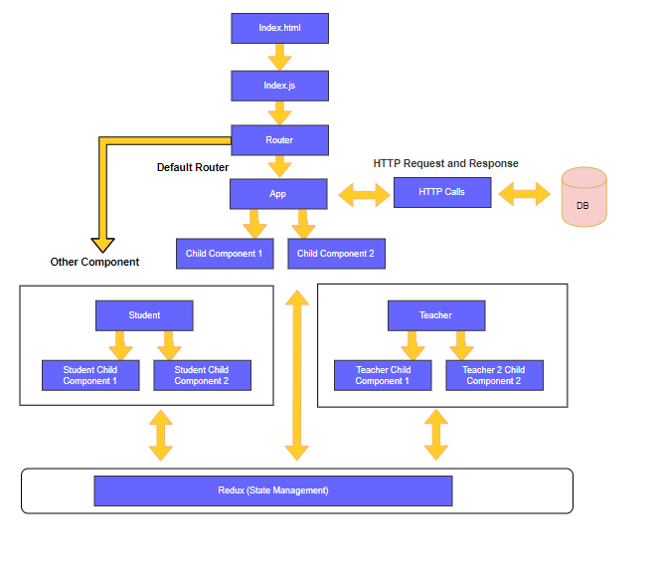

Description
  - This application sharing information through redux state.
  - As per above diagram, Redux maintains a global state accessible throughout the application.
  - The main purpose of Redux, it holding application state (global and module level)

Application Flow (With API)
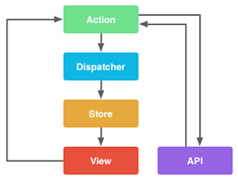

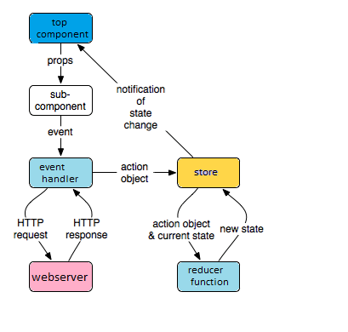

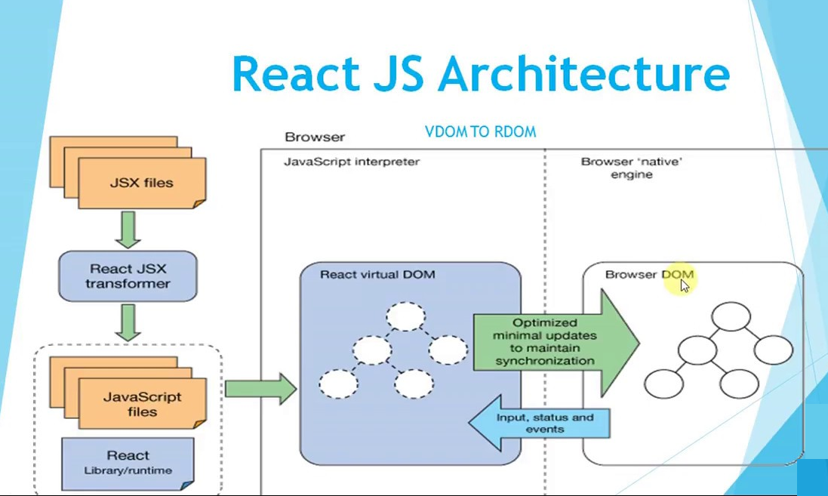

Virtual DOM
- The Virtual DOM (VDOM) is a programming concept where an ideal, or “virtual”, representation of a UI is kept in memory and synced with the “real” DOM by a library such as React DOM. This process is called reconciliation.
- Brings HTML into JavaScript Works with the virtual DOM Server-side rendering.
- The difference between the previous Virtual DOM representation and the new one will be calculated.
- Like the actual DOM, the Virtual DOM is a node tree that lists elements and their attributes and content as objects and properties. React’ s render () method creates a node tree from React components and updates this tree in response to mutations in the data model, caused by actions
- The Virtual DOM, providing higher performance and a cleaner user experience all around.
JSX
- JSX is a preprocessor step that adds XML syntax to JavaScript. It’s a XML-like syntax extension to ECMAScript without any defined semantics.
- JSX tags have a tag name, attributes, and children. If an attribute value is enclosed in quotes, the value is a string
- You can use React without JSX but JSX makes React a lot more elegant

Business Vision

Modules
<Detail about the modules and its imports, exports, declarations and providers>
<Number of module used in this application>
<Root module, initial route module and on demand module load (lazy load) if any>

Components
<Root component>
<Number of components are being used>
<Component hierarchy and its interaction>
<Data flow>

Metadata
<it represents component data like props required for the components>

Data binding – via Props or global state
React view engine will take care by using component life cycle method for initial and next renders

Services
<list of service methods is being used>
<GET, POST, PUT and DELETE request to API method>
<Set and Get values to share the value between components>
  - Axios is a JavaScript library used to make http requests from node.js or XMLHttpRequests from the browser and it supports the Promise API that is native to JS ES6.

  - Second feature that it has over fetch() is that it performs automatic transforms of JSON data.

Routing
Route configuration
<Provider store={store}>
<ConnectedRouter history={history}>
<Switch>
<Route path="/" component={App} />
</Switch>
</ConnectedRouter>
</Provider>

s

Front End Design

User Interface Design
<Number of pages/screens (approximate by function)
Number of style sheets
Folder structures for media, static content, dynamic pages etc.
Details of Integration with Process (Create, Review, Edit, Publish)
Details of Integration with Technology (Content management system, Source code control, environment config management)
Details of support for co-branding
Details of support for hiding/displaying/restricting access to fields based on user role
Development requirements
Administration/ Operational requirements
Testing requirements (testing all UI conditions, all UI’s, automated/regression test support etc.)>

Solution Strategy for Cross Cutting Concerns
Specify the approach for cross cutting concerns like input validation, exception handling etc.

Project Structure Definition
Sample Standard Project Structure from Create React App
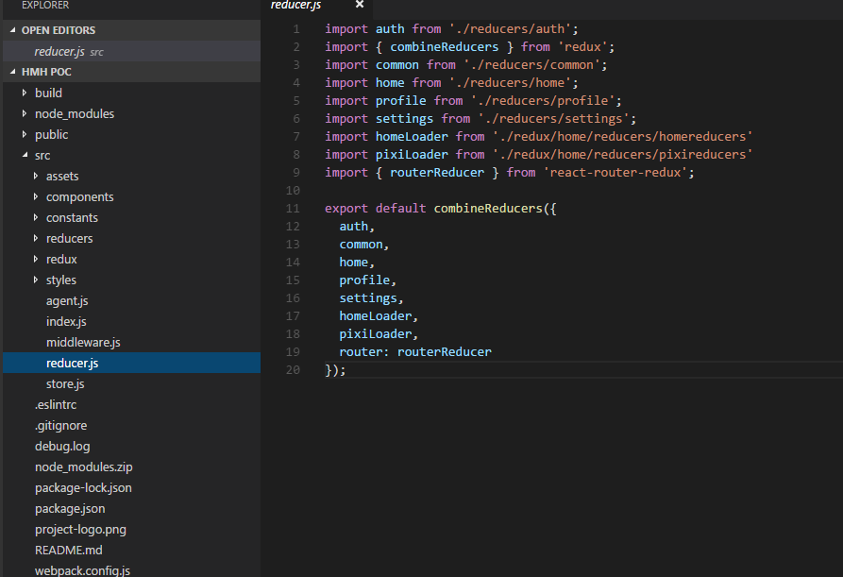

Backend Design
To be incorporated later based on the chosen technology stack

Consolidated Design View

Request Process Flow
<High-level view on the data flow architecture in the entire system like below picture.>
<The data flows from the services into the components and from parent components to their descendants (using Observables).>

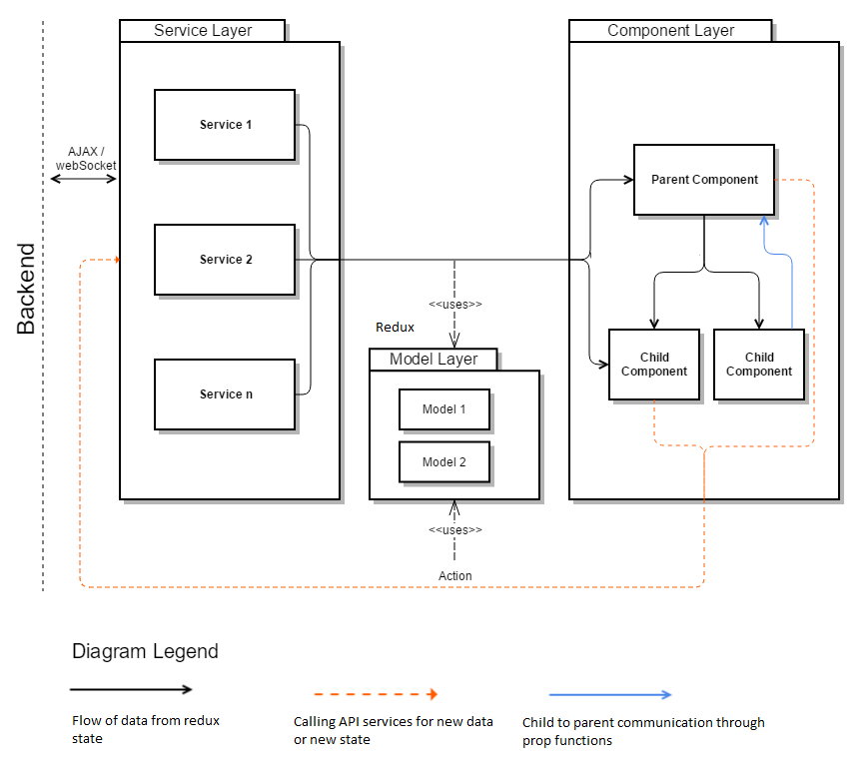

Request – Response Mapping
Screen Name | Screen Element | Service Name | Type of Service Operation | Request Field | Response Field | Remarks
<An unique name / identifier for the screen> | <Identify an element on the screen which gets mapped to a particular service response field / an element that triggers a service invocation> | <Specify the name of the service> | <Specify if is a GET operation or POST operation> | <For POST operation, map the screen element with service element> | <For GET operation, map the screen element with service element> | <Optionally, add any relevant comments>

Requirement – Solution Mapping
Requirement Id | Requirement Description | High Level Design Approach | Associated Files | Remarks
<Refer to the requirement id from requirement document> | <A high level description of the requirement> | <A high level overview of the solution approach> | <Refer to files from both front end / back end> | <Optionally, add any relevant comments>

Testing
Tools used: Jest, jasmine, karma for unit tests for end 2 end test
Type of test
Test cases description

Build & Deployment Strategy
Build for production version (build -- :prod)
Dist folder path and description

Change History
Version Number | Changes Made
V1.0 | <<First version>>
V1.1 | <<If the change details are not explicitly documented in the table below, reference should be provided here>>
V1.1 | Page No. | Changed by | Effective Date | Changes Effected
V1.2 | <<If the change details are not explicitly documented in the table below, reference should be provided here>>
V1.2 | Page No. | Changed by | Effective Date | Changes Effected

